**ORDER AND CASHIER MANAGEMENT SYSTEM**

**____________________________________________________________**

**____________________________________________________________**

**Members:**

**Herda, Crystal Joy**

**Provido, Ogille Dane**

**Zurita, Jesse**

**Labina, Jenifer**

**1. Objectives**

The primary objectives of the proposed system are focused on automating customer service processes and improving transaction efficiency. The key objectives include:

Develop a system that allows users to select multiple products in a single order.

Ensure seamless database integration for order management.

Provide an intuitive and efficient user interface.

Store order details securely in the database.

1. **System Design**

Features Implemented

**Order Management**: Allows users to select products and place orders.

**Cashiering Module**: Processes payments and generates receipts.

**Database Integration**: Stores transaction details securely.

**User Authentication**: Ensures access control for employees.

**Role-Based Access**: Differentiates access for cashiers and administrators.

**Sales Reporting**: Provides reports on sales transactions and revenue.

1. **Database Schema Diagram**

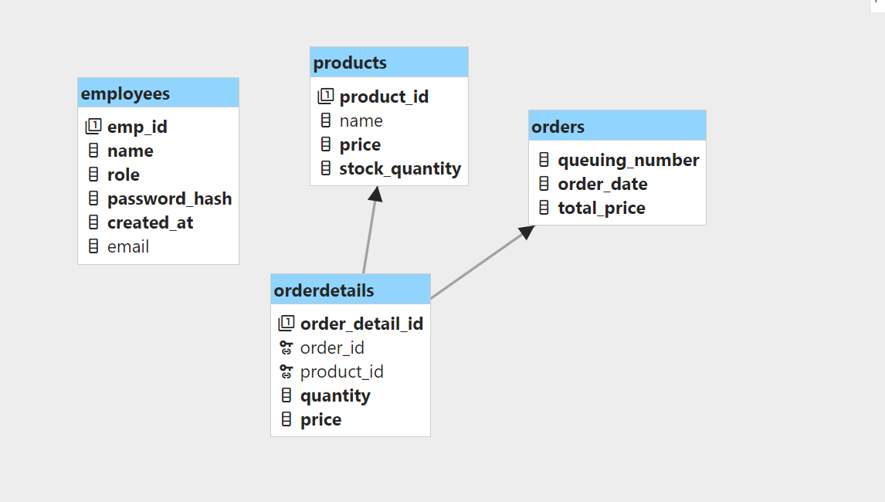

1. **Code Snippets**

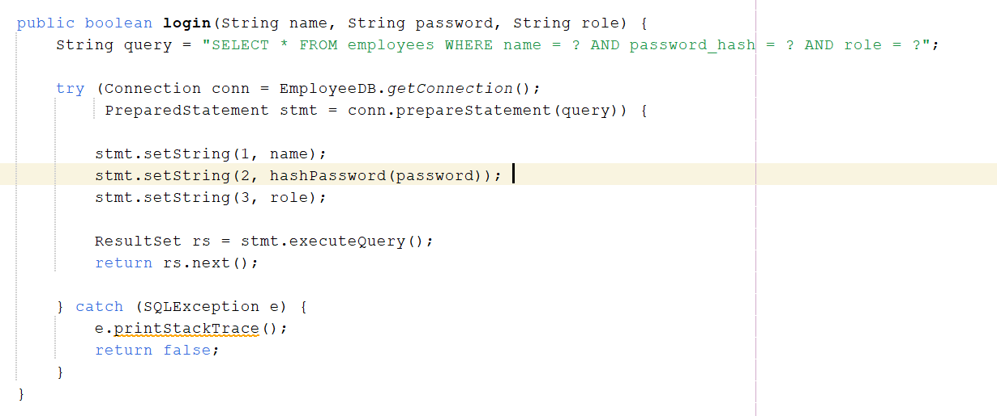 **Authentication System**

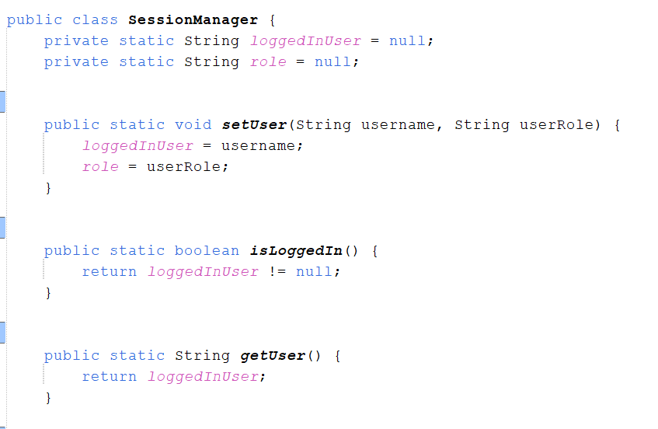**Session Management**

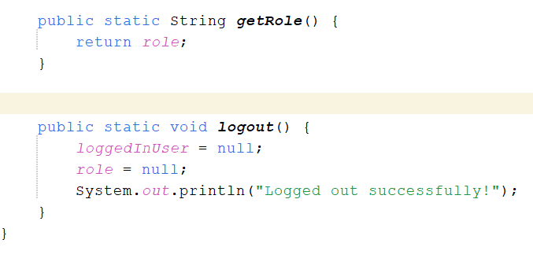

**5.Challenges Encountered & Solutions**

|  |  |
| --- | --- |
| **Challenges** | **Solutions Applied** |
| Secure Password Storage | Used SHA-256 hashing for password |
| Session Mangement | Implemented session tracking using a database table |
| Role-Based Access Control | Validated user roles before granting access |
| Efficient Query Execution | Optimized SQL queries for better performance |

1. **Conclusion**

The system successfully implements authentication and session management, ensuring secure login and role-based access. Future enhancements may include session expiration handling and multi-factor authentication for added security.

1. **Screenshots**

